Week 3 Gate 3 Assessment Report

Objective:
Checkout Flow Using Cucumber Framework
Open Catalog -> Search Product -> Add to cart -> Open cart -> Checkout -> Order confirmed

Prerequisites: .env file
Variables in .env:
1.BASE_URL
2.HEADLESS

Scenarios Covered:
Smoke Tests:
Command to run: mvn test -Dtest=RunCucumberTest -Dcucumber.filter.tags=@smoke
- Buy a single product end to end
Status: PASS

Scenario: Buy a single product from catalog
When I search for "headphones"
And the first product title is "Noise Canceling Headphones"
And I add the first item to the cart
Then the cart badge shows 1
When I open the cart
Then the cart has 1 line item
When I place the order
Then the order is confirmed

- Cart badge reflects the number of items added
Status: PASS

Scenario: Cart badge reflects number of items added
When I search for "headphones"
And the first product title is "Noise Canceling Headphones"
And I add the first item to the cart
And the catalog is open
And I search for "shoes"
And the first product title is "Running Shoes"
And I add the first item to the cart
Then the cart badge shows 2

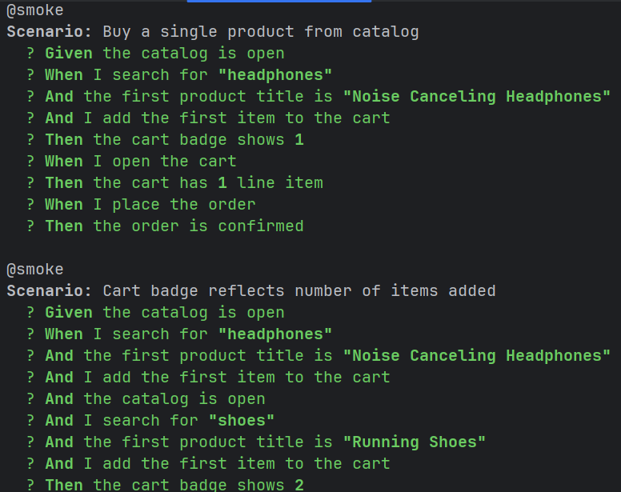

Regression Tests:
Command: mvn test -Dtest=RunCucumberTest -Dcucumber.filter.tags=@regression
- Buy across several products via Scenario Outline
Status: PASS

Scenario Outline: Buy across several products using examples
When I search for "<product>"
And I add the first item to the cart
Then the cart badge shows <count>
When I open the cart
Then the cart has <count> line item
When I place the order
Then the order is confirmed

Examples:
| product | count |
| headphones | 1 |
| shoes | 1 |
| lamp | 1 |

- A fresh cart is empty
Status: PASS

Scenario: A fresh cart is empty
When I open the cart
Then the cart has 0 line item

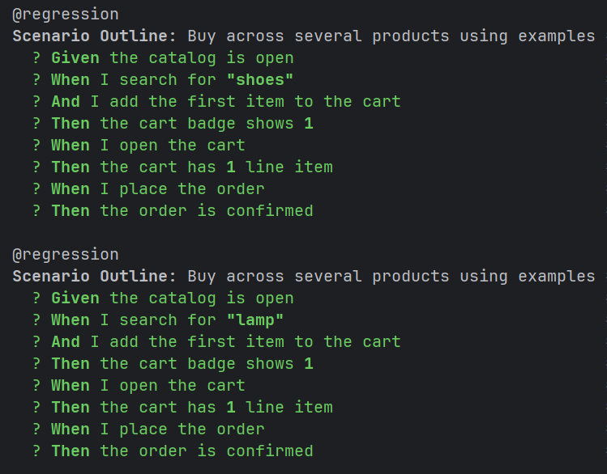
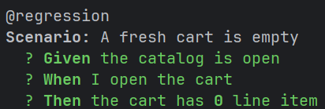

Negative Tests:
Command: mvn test -Dtest=RunCucumberTest -Dcucumber.filter.tags=@negative
- One deliberately failing scenario to demonstrate failure screenshot
Status: FAILED

Scenario: Deliberately checking incorrect cart count
When I search for "headphones"
And the first product title is "Noise Canceling Headphones"
And I add the first item to the cart
And the catalog is open
And I search for "shoes"
And I add the first item to the cart
Then the cart badge shows 1

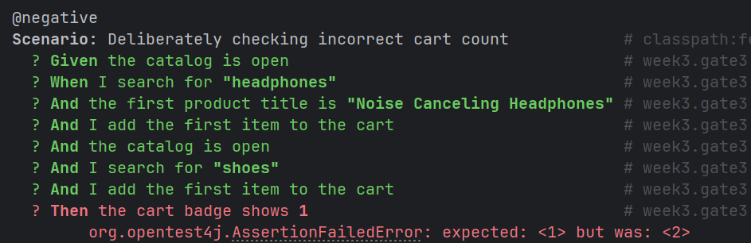

Expected cart badge count : 1
Actual cart badge count : 2

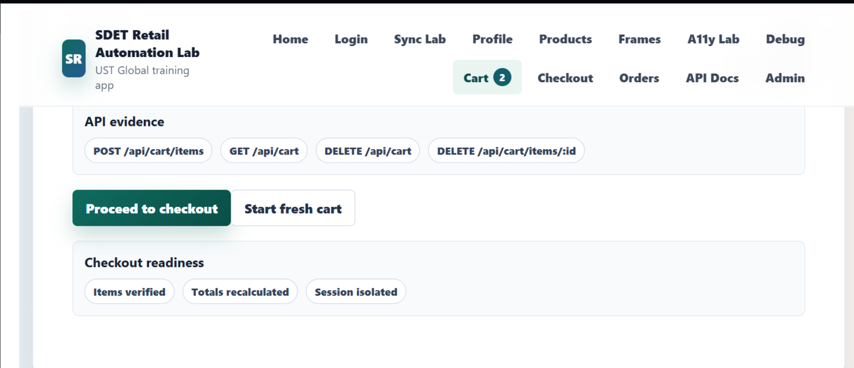

Reports
Extent Report
Path: SeleniumWeek3Assignment/test-output/SparkReport/Spark.html

Allure Report
Report cannot be made due to missing Allure in system
Command to create allure report: allure generate target/allure-results --clean -o target/allure-report

